University Of Engineering and Technology, Lahore
Computer Engineering Department

Course Name: Programming Fundamentals | Course Code: CMPE-112L
Assignment Type: Lab Report | Dated:
Semester: 1st | Session: 2026 Spring
Lab/Project/Assignment #: 10 | CLOs to be covered: CLO
Lab Title: Lambda, Os Library, Map | Teacher Name: Hafiz Muhammad Mubashar
Lab Evaluation:

CLO1 | Apply appropriate programming techniques to create executable programs to solve well defined problems
 | Level1 | Level2 | Level3 | Level4 | Level5 | Level6
(5)
Total |  |  |  |  |  | /5
Rubrics for Current Lab Evaluation
Scale | Marks | Level | Rubric
Excellent | 5 | L1 | Submitted all lab tasks, BONUS task, have good understanding.
Very Good | 4 | L2 | Submitted the lab tasks but have good understanding
Good | 3 | L3 | Submitted the lab tasks but have weak understanding.
Basic | 2 | L4 | Submitted the lab tasks but have no understanding.
Barely Acceptable | 1 | L5 | Submitted only one lab task.
Not Acceptable | 0 | L6 | Did not attempt
LAB No 1
Lab Goals/Objectives:
• Understand lambda (anonymous) functions.
• Learn to create and use lambda expressions.

Equipment Required:
• Computer/Laptop
• Python 3.x
• IDE (IDLE, VS Code, or PyCharm)

Theory:

A lambda function is a small anonymous function defined using the lambda keyword. It is used for simple operations without creating a named function. The os library provides functions to interact with the operating system, such as creating, renaming, deleting files and folders, and accessing directory information.

Lab Work:

Lambda Functions:
Task 1:
def cube(n):
return n**3
print(cube(5))
def square(n):
return n**2
print(square(5))

Result:
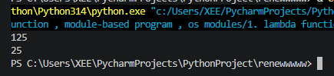

Task 2

a=lambda x:x*x*x
print(a(5))

Result:
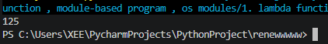

Task 3
def sum(x,y,z):
return(x+y+z)
x=1
y=2
z=3
print(sum(x,y,z))

Result:
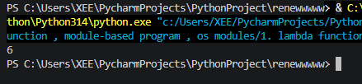

Task 4
a=lambda x,y,z:x+y+z
print(a(5,4,6))

Result:
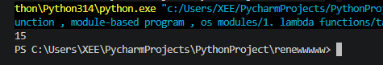

Task 5
a=[1,2,3]
for i in range(len(a)):
a[i]=a[i]**2
print(a)

Result:
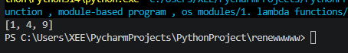

Task 6
f=open("pf.txt","a")
a=f.write("noor")
print(a)
f.close()

Result:
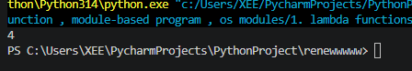

Import Os libraries:

Text File 1:
r=read
w=write
a=append
b=binary file

Text File 2:

r=read
w=write
a=append
b=binary file
f=open("15.txt")
a=f.read()
print(a)
f.close()

Task 1:
import os
for i in range(0,100):
os.mkdir(f"data{i+1}")

Result:
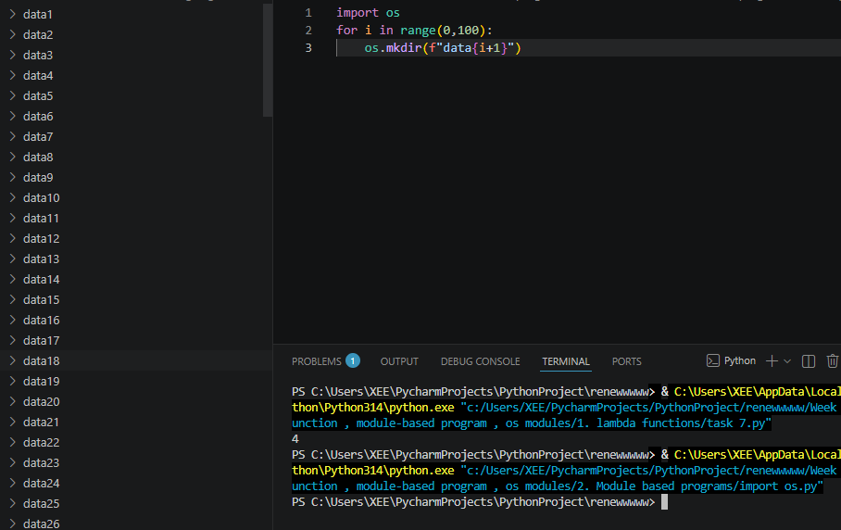

Task 2
import zainab
zainab.hello()

Result:
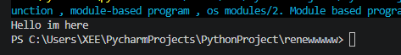

Task 3
def hello():
print("Hello im here")
if __name__ == "__main__" :
hello()

Result:
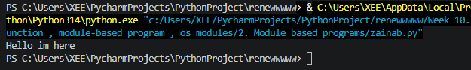

Os Module:

Task 1
import os

print(os.getcwd())

Result:
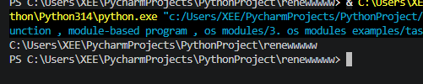

Task 2
import os

os.mkdir("NewFolder")
print("Folder created")

Result:
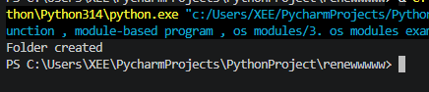

Task 3
import os

print(os.listdir())

Result:
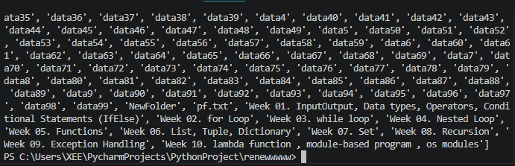

Conclusions:

In this lab, we learned how to use lambda functions for simple operations and explored the os library for performing file and directory management tasks. These concepts help write concise and efficient Python programs.

